Mrs. Cineus’ Wonder’s Weekly To-Do List
- Unit 4 Week 3 – April 26th –May 1st
- Once worksheet pages are complete screenshot with electronic device and send via remind.
- Assignments can be turned in as students complete them or all at one time, whichever is convenient for you
- Everyday students should complete 20 minutes and 20 minutes of I-Ready Reading.
Monday | Tuesday | Wednesday | Thursday | Friday
- Complete Unit 4 Week 3 Vocabulary in journal or on paper. Vocabulary words can be found on connected, in the words to know tab.  - I-Ready Reading for 20 minutes  - Reading 20 minutes | - Complete pages 60-64 from Ready job. Complete the “write” question.  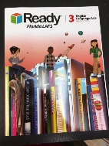  - I-Ready Reading for 20 minutes  - Reading 20 minutes | - Complete pages 171 from Your Turn Book.  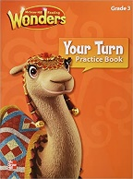  - Complete pages 82-83 from Ready Book. Complete the “write” question. | - Read the assigned story in student mailbox and take quiz use the link below. Don’t forget to take an AR test  https://www.getepic.com/students  Class code: pra0590  - Complete “Where is Mario’s Baseball Glove? ” from workshop folder,  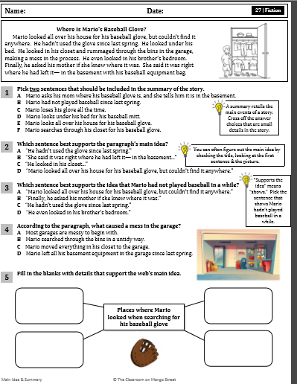 | Social Studies Assignment:  - Watch the Video about the state of Alabama and New York and write 3 interesting fact in your journal.  https://www.youtube.com/watch?v=sBtTter1Cmk  https://www.youtube.com/watch?v=aCIxwk7dwA8

